The SYNCROFLEX Festival of Future Stars
South Island National Equestrian Centre
McLeans Island Road, Christchurch
14-15 April 2018

Incorporating:
South Island Young Dressage Horse Championships
Mitavite Rising Stars led and ridden showing classes
Zilco Musical Freestyles Level 5 and above
Dressage Levels 1 – 9
Non-Graded dressage
Pony dressage

Entries Close: 26 March 2018

South Island Young Dressage Horse Championship Classes
Each Age Group Champion will receive a dress rug and Sash, Reserve Champions will receive a Sash. All kindly donated by SYNCROFLEX.

EQUITENZ 4 Year Old YOUNG DRESSAGE HORSE
Saturday | 1 |  | Equestrian Australia Young Dressage Horse Commanded Test 4 yr old - First round State Championships | $50 | NO PRIZE MONEY ROUND 1
Sunday | 2 | FEI | FEI 2017 Dressage test for 4 year old horses |  | 60 | 50 | 40 | 30
EQUISOLAIRE 5 Year Old YOUNG DRESSAGE HORSE
Saturday | 3 |  | Equestrian Australia Young Dressage Horse Commanded Test 5 yr old - first round State Championships | $50 | NO PRIZE MONEY ROUND 1
Sunday | 4 | FEI | FEI 2017 Preliminary test for 5 year old horses |  | 60 | 50 | 40 | 30
SYNCROFLEX 6 Year Old YOUNG DRESSAGE HORSE
Saturday | 5 |  | Equestrian Australia Young Dressage Horse Commanded Test 6 yr old - first round State Championships | $50 | NO PRIZE MONEY ROUND 1
Sunday | 6 | FEI | FEI 2017 Preliminary test for 6 year old horses |  | 60 | 50 | 40 | 30
HUMMINGBOARD 7 Year Old YOUNG DRESSAGE HORSE
Saturday | 7 | FEI | FEI 2017 Preliminary Dressage Test for 7-yr old horses | $50 | NO PRIZE MONEY ROUND 1
Sunday | 8 | FEI | FEI 2017 Final Dressage Test for 7-year old horses |  | 60 | 50 | 40 | 30

Dressage Section – Registered
Each Level Champion will receive a dress rug and Sash, Reserve Champions will receive a Sash. All rugs kindly donated by ZILCO Equestrian Products

Class Test
Saturday |  | 9 |  | 1A | Level 1 |  |  |  | $ 20 | ** | 30 | 25 | 20
Sunday |  | 10 |  | 1B | Level 1 |  |  |  | $ 20 | 35 | 30 | 25 | 20
 |  | 11 |  | 1D | Level 1** |  |  |  | $ 20 | 35 | 30 | 25 | 20
Saturday |  | 12 |  | 2A | Level 2 |  |  |  | $ 20 | ** | 30 | 25 | 20
Sunday |  | 13 |  | 2B | Level 2 |  |  |  | $ 20 | 35 | 30 | 25 | 20
 |  | 14 |  | 2D | Level 2** |  |  |  | $ 20 | 35 | 30 | 25 | 20
Saturday |  | 15 |  | 3A | Level 3 |  |  |  | $ 20 | ** | 30 | 25 | 20
Sunday |  | 16 |  | 3B | Level 3 |  |  |  | $ 20 | 35 | 30 | 25 | 20
 |  | 17 |  | 3D | Level 3 ** |  |  |  | $ 20 | 35 | 30 | 25 | 20
Saturday |  | 18 |  | 4A | Level 4 |  |  |  | $ 20 | ** | 30 | 25 | 20
Sunday |  | 19 |  | 4B | Level 4 |  |  |  | $ 20 | 35 | 30 | 25 | 20
 |  | 20 |  | 4D | Level 4** |  |  |  | $ 20 | 35 | 30 | 25 | 20
Saturday |  | 21 |  | 5A | Level 5 |  |  |  | $ 20 | ** | 30 | 25 | 20
Sunday |  | 22 |  | MFS | Level 5 Musical Freestyle |  |  |  | $ 20 | 35 | 30 | 25 | 20
 |  | 23 |  | 5D | Level 5** |  |  |  | $ 20 | 35 | 30 | 25 | 20
Saturday |  | 24 |  | 6A |  | Level 6 |  |  | $ 20 | ** | 30 | 25 | 20
Sunday |  | 25 |  | PSG 2018 |  | Level 6** |  |  | $ 20 | 35 | 30 | 25 | 20
 |  | 26 |  | MFS |  | Level 6 Musical Freestyle |  |  | $ 20 | 35 | 30 | 25 | 20
 | Saturday | 27 |  | FEI INT 1  2018 |  | Level 7 |  |  | $ 20 | ** | 30 | 25 | 20
 | Sunday | 28 |  | FEI Int A/B Level 2018 |  | L7 Musical Freestyle ** |  |  | $ 20 | 35 | 30 | 25 | 20
 | Saturday | 29 |  | FEI INT B 2018 |  |  | Level 8 |  | $ 20 | ** | 30 | 25 | 20
 | Sunday | 30 |  | FEI Int A/B Level 2018 |  |  | L8 Musical Freestyle** |  | $ 20 | 35 | 30 | 25 | 20
 | Saturday |  | 31 | FEI GP 2018 |  |  |  | Level 9 | $ 20 | ** | 30 | 25 | 20
 | Sunday |  | 32 | FEI GPFS 2017 |  |  |  | L9 Musical Freestyle** | $ 20 | 35 | 30 | 25 | 20
 | Sunday |  | 54 | Para TOC |  |  |  | National or FEI | $13 | Rosettes
 | Sunday |  | 55 | Para |  |  |  | Musical Freestyle | $13 | Rosettes

Dressage Pony Section – Registered
Each Level Champion will receive a dress rug and Sash, Reserve Champions will receive a Sash. All rugs kindly donated by ZILCO Equestrian Products

Class |  | Test
Saturday | 33 | 1A | Level 1 | $ 20 | ** | 30 | 25 | 20
Sunday | 34 | 1B | Level 1 | $ 20 | 35 | 30 | 25 | 20
 | 35 | 1D | Level 1** | $ 20 | 35 | 30 | 25 | 20
Saturday | 36 | 2A | Level 2 | $ 20 | ** | 30 | 25 | 20
Sunday | 37 | 2B | Level 2 | $ 20 | 35 | 30 | 25 | 20
 | 38 | 2D | Level 2** | $ 20 | 35 | 30 | 25 | 20
Saturday | 39 | 3A | Level 3 | $ 20 | ** | 30 | 25 | 20
Sunday | 40 | 3B | Level 3 | $ 20 | 35 | 30 | 25 | 20
 | 41 | 3D | Level 3 ** | $ 20 | 35 | 30 | 25 | 20
Saturday | 42 | 4A | Level 4 | $ 20 | ** | 30 | 25 | 20
Sunday | 43 | 4B | Level 4 | $ 20 | 35 | 30 | 25 | 20
 | 44 | 4D | Level 4** | $ 20 | 35 | 30 | 25 | 20
** Sponsored prize kindly donated by ZILCO Equestrian Products

Dressage Classes Non-Graded
Each Level Champion and Reserve Champion will receive Sashes. Rosettes 1st-6th

Non-Graded A
Class Test
Saturday | 45 | 0:A | Introductory | $ 13 | Rosettes
Sunday | 46 | 0:B | Introductory | $ 13
 | 47 | 0:C | Introductory** | $ 13
Non-Graded Level 1
Saturday | 48 | 1A | Level 1 | $13 | Rosettes
Sunday | 49 | 1B | Level 1 | $13
 | 50 | 1D | Level 1** | $ 13
Non-Graded Level 2
Saturday | 51 | 2A | Level 2 | $ 13 | Rosettes
Sunday | 52 | 2B | Level 2 | $ 13
 | 53 | 2D | Level 2 ** | $ 13

MITAVITE RISING STARS SHOWING SECTION
These classes will be judged on paces, temperament and suitability for dressage.
Open to any breed of horse.
Colts (Youngstock) and Stallions – See rules later in schedule
Breastplate numbers are to be used.

Entry Fee $10.00 per class. Classes Start Saturday 8.30am with Led Section followed by Ridden Section – 1 ring only.

Mitavite feed vouchers awarded to Champions. Mitavite products for 1st,2nd and 3rd placegetters in each class.

RISING STAR – LED SECTION
Class 55 Colt or Filly Foal

Class 56 Yearling Colt or Gelding
Class 57 2yo Colt or Gelding
Class 58 3yo Colt or Gelding

Class 59 Yearling Filly
Class 60 2yr old Filly
Class 61 3yr old Filly

Class 62 Stallion or Gelding 4-6 yrs old
Class 63 Stallion or Gelding 7 yrs and over

Class 64 Mare 4-6 yrs
Class 65 Mare 7 yrs and over

Rising Star Champion and Reserve 3yo and under – judged from winners of Classes 55 - 61
Rising Star Champion and Reserve 4yo and over – judged from winners of Classes 62 - 65

RISING STAR – RIDDEN SECTION
These classes will be judged on paces, temperament and suitability for dressage

Open to any breed of horse over 147.5cm

Class 67 Ridden Gelding or Stallion 4yo – 7 yo

Class 68 Ridden Gelding or Stallion over 7yo

Class 69 Performance Gelding or Stallion 4yo - 7yo

Class 70 Performance Gelding or Stallion over 7yo

Class 71 Ridden Mare 4yo – 7yo

Class 72 Ridden Mare over 7yo

Class 73 Performance Mare 4yo – 7yo

Class 74 Performance Mare over 7yo

Rising Star Champion and Reserve 4 – 7 yo – judged from classes 67, 69, 71 and 73

Rising Star Champion and Reserve over 7yo – judges from classes 68, 70, 72 and 74

Note - Performance class workouts may include, according to age groups - transitions, lateral work, simple changes through walk and/or trot and flying change as an option.

Dressage Championships
- Points are allocated 30 for 1st, to 2 for 15th in all classes
- Points are allocated 45 for 1st, to 3 for 15th in all classes denoted by **
- For Grade Champions & Reserves: Level 1 – Level 9 and Ponies L1 -4: The horse with the highest aggregate allocated points from specified classes will be the Championship winner. In the event of a tie, the combination with the highest place in the ** Class is the winner. If there is still a tie, the combination with the highest average % in all classes will be the winner. If there is a further tie, the combination with the highest aggregate collective marks in the final ** will be the winner. The system will not allow an equal placing in the ** class.
- To be eligible for championship points you must achieve a minimum score of 57%. If no horse scores over 57% then no Champion will be awarded.

Young Horse Dressage Classes
- Combinations to enter both age group classes which are covered by one entry fee of $50
- YDH tests can be obtained from: http://www.fei.org/fei/your-role/organisers/dressage/tests and http://www.equestrian.org.au/Dressage-YH. If you need help to find the correct test email ponytail007@gmail.com for a copy.
- All tests will be ridden one horse at a time. Please refer to rules for riding each test as shown on individual test sheet. Rules for YDH
- For 4, 5, 6, 7 year old horses and 4, 5, 6 year old ponies only, based on the official birth date, Southern Hemisphere born horses - 1st August Northern Hemisphere born horses - 1st January.
- Riders may compete more than one horse in the Championship.
- No prior performance qualification required.
- Proof of age must be supplied with entry or entry will not be accepted.
- No prize money for first round, rosettes 1st to 4th.
- Combinations must contest both rounds to be eligible for a championship.
- Equal Placings - In the case of equality in any qualifying class, the higher collective marks will determine the higher placing. If the competitors are still equal, then the higher co-efficient marks will determine the placings.
- Championships Points & Presentation of Prizes: Points will be awarded, 1st 20, 2nd 18, and so on down to 10th place.
- First round only may be commanded
- Whips may be used in the 4,5,6 yr old classes only
- First round - For 4,5 and 6 year old tests the judges will sit together at either E or B. Second Round, the judges panel will sit at C.
- For 7 year old Young Horse classes, the technical judge will sit at C and the two judges assessing the quality will sit together at B or E.
- Please complete the attached breeding record.

Stallions & Colts
- A Steward will order any stallion/colt considered out of control or to be causing undue disquiet to other horses from the ring without recourse from the stallion/colt's owner/exhibitor/competitor.
- It is compulsory for all stallions and colts, except foals, to wear two (2) official 'S' identification badges, one attached to each side of their bridle, at all Shows/Events at all times. The rider/handler must also wear two (2) RAS official armbands (one on each arm) when in the ring. 'S' badges to be purchased from RAS Head Office or ESNZ; armbands from RAS Head Office.

- Handlers and riders of stallions/colts must wear an approved hi viz vest at all Shows/Events when outside the showing ring. Vests can be purchased from RAS Head Office.

- Stallions and colts can only be tied to a truck or float if they are under constant supervision or are tied within an approved solid framed portable yard that is attached the outside of the truck or float. Otherwise they must be confined within their float or truck.
Competition Conditions
- Rules: All competitions will be run under ESNZ GR’s, VR’s & ESNZ Rules for Dressage (ED 2016)

- Responsibility: It is the Rider or Persons Responsible obligation, to read and understand the conditions for this show. Conditions are published in the program and this schedule.

- Amendments: The OC reserves the right to alter the program/schedule and/or prize money within the ESNZ GR’s/Dressage NZ Rules.

- Upgradings: Please notify Sarah Hazlewood (021 270 0283) immediately. Failure to do so prior to show will result in no refund and additional entry fees charged. Other changes at event, a fee of $15 per class is applicable.

- Musical CDs must be formatted in either: MP2, MP3 or CD, We cannot guarantee any other file format will play. You are welcome to ask to have your CD tested before the musicals begin.
- Presentation of Prizes & Prize Money: See article 485. Presentation times will be advised in the program. The OC reserves the right to substitute prize money with goods to the equal value. Dressage Prize money will only be paid out on scores of 57% or higher for all registered horses/ponies and will be paid by Direct Credit within 21 days of the event. The OC reserves the right to withhold prize monies should a placegetter not attend an advertised prize giving. Riders who have conflicting class times must nominate another person to Sarah Hazlewood or Sally Steele via the event office to collect their prizes/rosettes at the prize giving. Please ensure you bank account details are loaded on www.equestrianentries.co.nz, this is your responsibility as we will not be contacting you if you have not listed it and no prize money be paid after 31 May 2018.
- Draw: If required, a revised draw and/or start times for the following day’s competition will be available 7.00 pm Saturday on the results board. The OC reserves the right to alter the program to ensure the smooth running of the event. It is the rider’s responsibility to check any new times posted.
- Equal Placings: In the case of equality in any qualifying class, the higher collective marks will determine the higher placing. If the competitors are still equal then the higher co-efficient marks will determine the placings. If there is still an equality of points, the competitors are given the same placing.

- Riders with more than 2 horses: The OC will make every effort to ensure that riders have at least 60 minutes between rides. However, if this is not possible owing to the scheduling of classes, the maximum time possible between rides will be allocated.
- The Organising Committee reserves the right to alter, change, or delete any part of this schedule at any time with all due notice being given to concerned parties.

General Venue Conditions

- Dogs must be on a lead at all times.
- No smoking in any buildings or in stable areas.
- Neither Canterbury Dressage nor any representative of these bodies, accepts any liability for any loss, damage, injury or illness to horse/pony/rider, spectators, land, vehicles or any personal property whether caused by their negligence or breach of contract in any way whatsoever.
- Canterbury Dressage shall not be liable for the safety of any goods/equipment or the loss of, or damage to such goods and equipment, brought in/stored at the venue, during the period of use.
- Any damage to SINEC facilities to be reported immediately to the Office.
- Safety hats must be worn at all times when schooling at the SINEC.
- All horses and ponies on the grounds must be entered at the event unless the OC gives express permission otherwise.

Code of Conduct
- In all equestrian sports the horse must be considered paramount.
- The well-being of the horse shall be above the demands of breeders, trainers, riders, owners, dealers, organisers, sponsors or officials.
- All handling and veterinary treatment must ensure the health and welfare of the horse.
- The highest standards of nutrition, health, sanitation and safety shall be encouraged and maintained at all times.
- Adequate provision must be made for ventilation, feeding, watering and maintaining a healthy environment during transportation.
- Emphasis should be placed on increasing education in training and equestrian practices and on promoting scientific studies in equine health.
- In the interests of the horse, the fitness and competence of the rider shall be regarded as essential.
- All riding and training methods must take account of the horse as a living entity and must not include any technique considered by the FEI to be abusive.
- National Federations should establish adequate controls in order that all persons and bodies under their jurisdiction respect the welfare of the horse.
- The national and international Rules and Regulations in equestrian sport regarding the health and welfare of the horse must be adhered to not only during national and international events, but also in training.
- Competition Rules and Regulations shall be continually reviewed to ensure such welfare.

Entry and Accommodation Conditions
Entries must be received by 5pm 16 March 2018
  - All entries to be submitted via www.equestrianentries.co.nz
  - Payment is to be made to Canterbury Dressage Account: 02 0820 0359529 00. For your entry to be accepted you must pay your entry fee prior to the closing date of entries. Please advise the name of the rider in the reference section.
  - Draw will be available on equestrian entries with the latest up-to-date version available 12 April 2018
  - Withdrawals must be submitted on attached form to gain a refund
  - All stabling/camping charges are for Friday night through to Monday (day included)
  - Only entries received and paid for by the closing date will be accepted

Rider Event Levy
$16 per rider, Non Refundable.

Camping
- Parking and camping areas will be defined. Some areas will be restricted to on site camping/parking only. Day competitors must only park in designated day parking areas.
- Please be tidy and use bins for all other rubbish.

Horse Identification, Accommodation & Wash Down Bays
- ESNZ horse identification numbers must be worn at all times when competing. When not competing, all horses should have ID tags or ESNZ numbers attached. It is requested that during non-competition times these ID tags also include horse and person responsible name and contact.
- All yards/pens/stables are to be left properly mucked out. Horse muck bins will be located near each yard/stable area for this purpose.
- No form of temporary yarding is permitted
- Please keep wash down bays clean at all times

Important Contact Details

For Emergencies Dial 111
24 Hour Medical – 24 Hour Surgery, 401 Madras Street, 03 365 7777
Feed Supply - Farmlands, 144 West Coast Road, Yaldhurst, 03 342 9245
Event Office – 03 359 6192 Office Convener – Sally Steele 0212145260
Event Manager – Aubrey McRae Chief Steward – TBA
Event Secretary – Sarah Hazlewood 021 2700283

Event Reception Opening Hours
The Event Reception is situated in the office area inside the Glyn East Hall, riders please address all queries to this area.

Saturday | 14 April | 7.00am – 5.00 pm
Sunday | 15 April | 7.00am – 5.00 pm

Horse Accommodation Fees
Horse accommodation and camping covers arrival from Friday 13 April to departure on Monday 16 April
Outside these dates additional charges will be incurred direct to SINEC. Please contact the SINEC direct http://www.sinec.co.nz/ to book additional dates.

Stables $20 per day
Covered Yards $20 per day
Uncovered Yards $20 for Friday to Monday

Camping Fees
Non Powered $20.00 for the Fri to Mon
Powered $25.00 per day

Horse Event Levy
Ground Fee $20.00 per horse for event

Arena Familiarisation

11am – 11:30am Arena 1 & 2 walk around outside of arenas at walk, ridden or lead.

SYNCROFLEX Festival of Future Stars 2018 Horse Details Form

This form is to be completed by YDH riders and all showing entrants

Name of Horse | Reg # | Sex | DOB | Name Rider
Name of Breeder | Sire |  | Dam | Sire of Dam

Name of Horse | Reg # | Sex | DOB | Name Rider
Name of Breeder | Sire |  | Dam | Sire of Dam

Name of Horse | Reg # | Sex | DOB | Name Rider
Name of Breeder | Sire |  | Dam | Sire of Dam

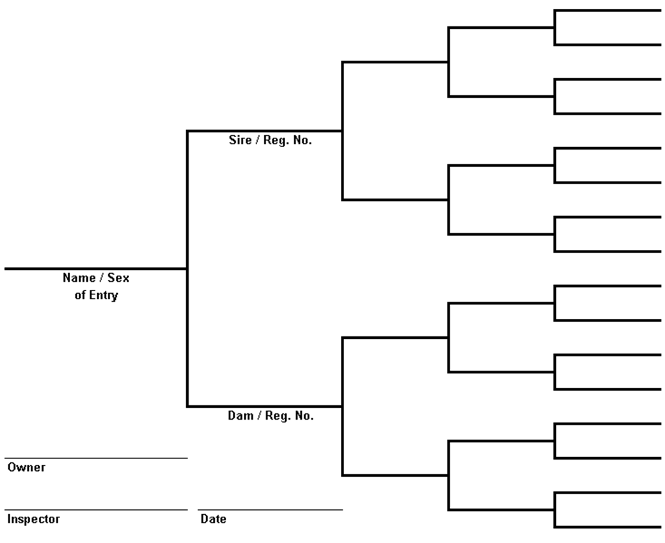

Email Completed form to canterburyentries@gmail.com

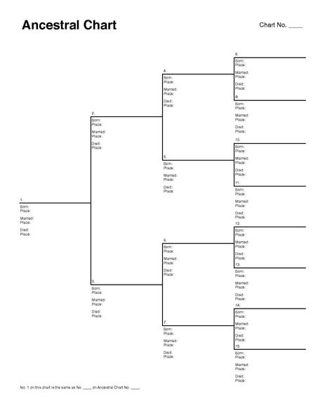

OFFICIAL WITHDRAWAL FORM
- There will be no refunds unless this Official Withdrawal Form is completed.
- To be eligible for any refund, notification of withdrawal must be received by 3pm Thursday 12th April. Any withdrawals after this time MUST be accompanied by a Vet, Blacksmith or Doctors certificate.
- Unless accompanied by doctor or vet/blacksmith certificate
- $20 Rider Event Levy is non-refundable. Equestrian Entries fee is non-refundable.
- Stabling & Camping fees will be refunded.

This refund form and certificates must be received no later than 5pm 21 April 2018 to receive a refund.

Withdrawal Form and Certificates must be emailed to the Treasurer: Charmaine Racke c.racke@xtra.co.nz Or post to PO Box 630, Christchurch 8140,

Horse(s)

Rider

Postal Address

Phone Number

Class Numbers

Class Fees

Total Entries Paid $

Equestrian Online Entry Levy $

Entertainment Paid $

Stabling & Camping Paid $

TOTAL PAID $

Less:

Rider Event Levy $ 16.00

TOTAL REFUND $

Bank Account Number

Phone

For office use: Cheque Number:

